***SGD LAB EXP – 6***

**Name** : Aditi Chhajed; **Reg. No.** : 221081009

**Branch** : IT ; **Course Instructor** : Prof. Vedashree Awati

Name : Aditi Chhajed

Reg.No : 22108100

***Aim:***

Add PostGIS data to QGIS.

***Theory:***

* ***Quantum GIS (QGIS)*** *is a free, open-source Geographic Information System (GIS) platform that allows users to create, visualize, analyze, and edit geospatial data on their desktop. QGIS is widely recognized as a leading alternative to commercial GIS applications like Esri’s ArcMap and ArcGIS Pro, offering extensive functionality for cartography, spatial analysis, and database integration.*
* *QGIS stands out due to its* ***user-friendly interface and robust plugin ecosystem****, which enables users to extend its capabilities with specialized tools for data visualization, spatial modeling, and data management. QGIS supports a wide range of vector and raster formats, making it highly versatile for various GIS tasks, from simple map creation to advanced geoprocessing workflows.*
* *A* ***key feature of QGIS is its seamless integration with PostGIS****, a* ***spatial extension of the PostgreSQL database****. This pairing offers powerful options for* ***storing, querying, and analyzing spatial data****. Users can* ***connect directly to PostGIS databases, visualize spatial tables, and perform SQL-based geospatial operations*** *without leaving the QGIS environment. This combination facilitates advanced cartographic outputs, real-time data interaction, and high-performance spatial processing.*
* *Additionally, QGIS's flexibility allows it to work with other open-source tools such as OpenJUMP, which is often preferred for specific spatial querying and geoprocessing tasks. Together,* ***QGIS and PostGIS provide a comprehensive, cost-effective solution*** *for GIS professionals, researchers, and enthusiasts looking to manage and analyze geospatial data with precision and efficiency.*

***Implementation:***

1. **Add PostGIS Data to QGIS**

* Open QGIS. It'll be the *QGIS Desktop 3.x* choice from the QGIS folder in your Start menu.



* Double-click the **New Empty Project** option under **Project Templates**.

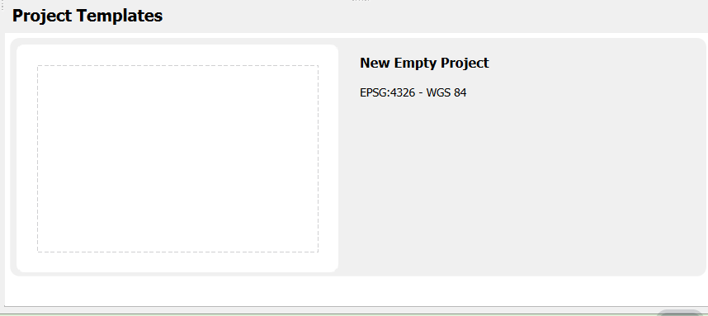  
  
The basic elements of the application GUI are similar to ArcMap/ArcGIS Pro's.

The **Layers panel** in the lower left of the window lists the project layers and their symbology, while the much wider pane to the right displays the layer features themselves.  Across the top of the window is a set of toolbars that can be moved to custom positions by the user.  
  
Above the Layers panel is the **Browser panel**, which provides an interface for browsing data sources.  Moving from top to bottom:

* + Favorites - for enabling easy access to frequently used folders on your file system
  + Spatial Bookmarks - for saving map extents that you'd like to return to later
  + Home - for accessing data located within your folder in C:\Users
  + C:\ - for accessing data anywhere on your hard drive  
      
    The folder navigation items above can be used to add file-based datasets to your project, such as Esri shapefiles or CSV files.
  + GeoPackage - for data in an interchange format from the Open Geospatial Consortium (OGC)
  + SpatiaLite - for data stored in a [SpatiaLite database(link is external)](http://en.wikipedia.org/wiki/SpatiaLite" \t "_blank) (another free and open-source spatial database extension similar to PostGIS, built to add spatial functionality to an [RDBMS called SQLite(link is external)](http://en.wikipedia.org/wiki/SQLite))
  + PostgreSQL - for PostGIS data
  + SAP HANA - for data stored in SAP HANA spatial databases
  + MS SQL Server - for data stored in Microsoft SQL Server spatial databases
  + Oracle - for data stored in Oracle Spatial databases
  + WMS/WMTS - for data streamed via a Web Mapping Service or Web Map Tile Service
  + Vector Tiles - for adding vector-tiled basemaps
  + XYZ Tiles - for adding raster-tiled basemaps
  + WCS - for data streamed via a Web Coverage Service
  + WFS - for data streamed via a Web Feature Service
  + ArcGIS REST Servers - for map service or feature service data published via an ArcGIS Server instance
* **Right-click on the PostgreSQL entry and select New Connection.** 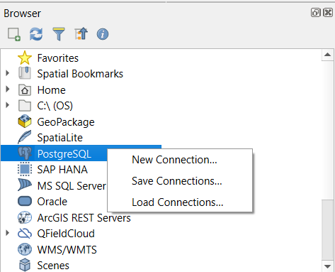
* In the **Create a New PostGIS connection** dialog supply the following information. (See Figure 3.1, below.)
  + Name: **Lesson3**
  + Service - *(leave blank)*
  + Host: **localhost**
  + Port: **5432**
  + Database: **Lesson3db**
  + SSL mode: **disable**
  + Session role - (*leave blank*)
* The simple way is to enter your authentication parameters under the Basic tab.  They will be stored as part of the QGIS project file (.qgs), assuming you save your work, where they could be read fairly easily.

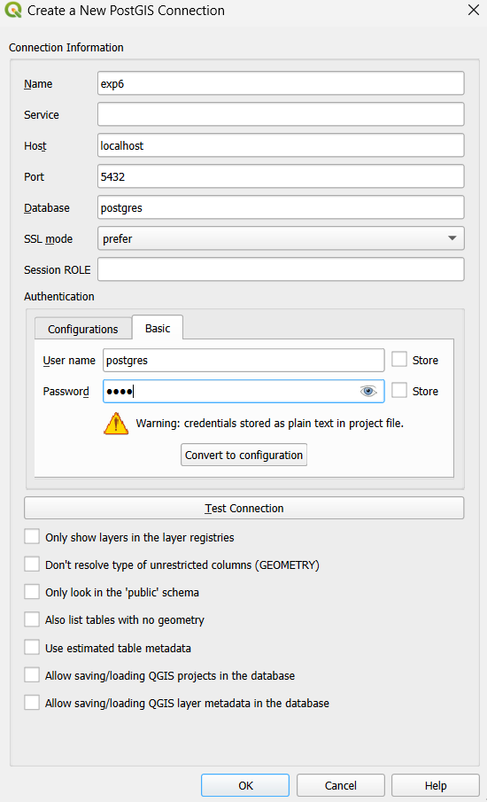

* You should click the **Test Connection** button to make sure you have typed things correctly.

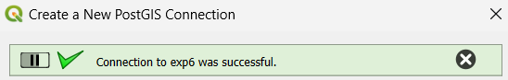

* Click **OK**to create the connection and dismiss the dialog.
* **exp6 should now appear as a PostgreSQL data source.**
* Now, click the arrow next to the **exp6** entry to expand the list of schemas made available through that connection.
* The **Enter Credentials** dialog pops up, so I supply the postgres user name and the password that I established for it.

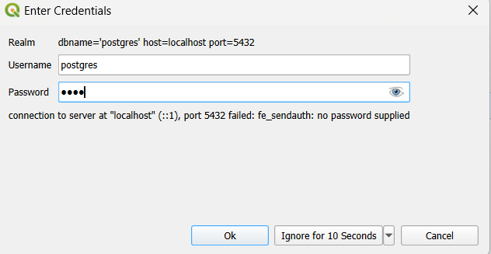

* Expand the list of layers available in the nyc\_poi schema. You should see the **pts**, **lines,**and **polys**tables created early in the last section and also the **mixed**table created. One of the convenient features of QGIS is that it automatically creates separate layers for each geometry type in a multi-geometry table, like our **mixed**table.  The mixed layers can be differentiated by the icons that indicate the geometry type.

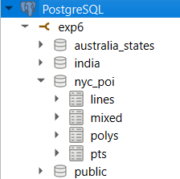

* Highlight all 4 nyc\_poi datasets and drag them onto the map. **THIS RAISED AN ERROR.**

**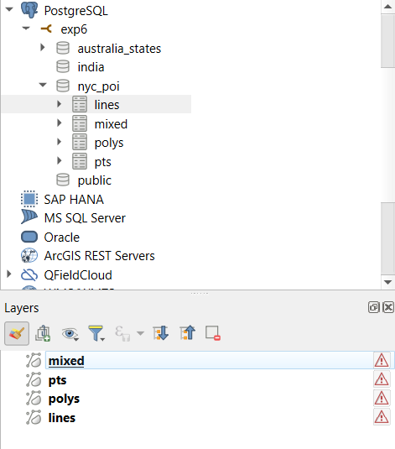**

**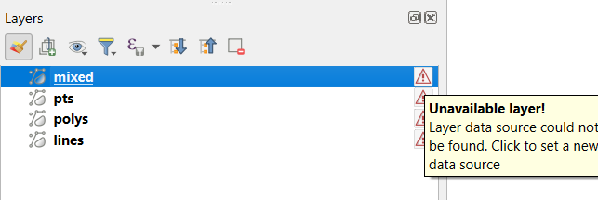**

**This made me realise that the data for geometry entered for exp5 might have been faulty. Hence, I had to update all the geometry data in the tables – pts, lines, polys and mixed.**

**Here are the update queries used to update the tables.**

* + 1. **nyc\_poi.pts-**

**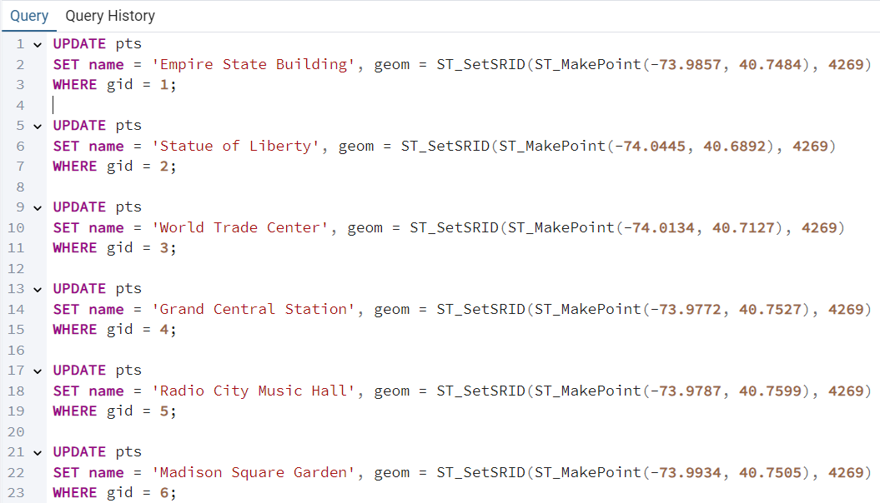**

**As opposed to the previous experiment – now I can see the ”*map”* icon.**

**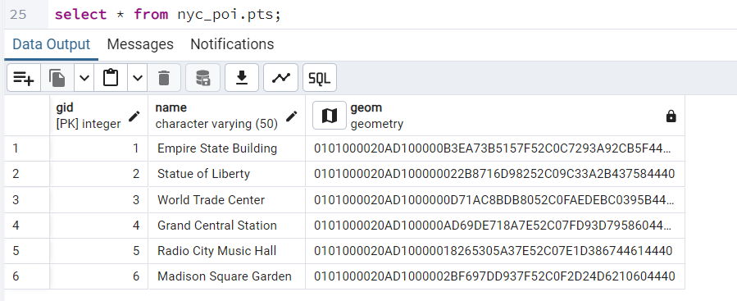**

* + 1. **nyc\_poi.lines-**

**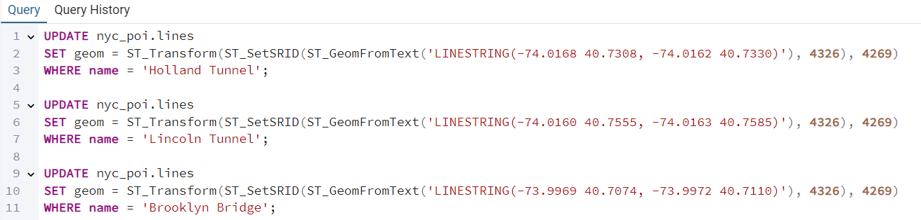**

* + 1. **nyc\_poi.polys-**

**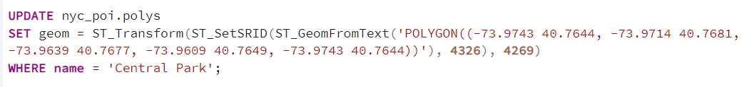**

* + 1. **nyc\_poi.mixed-**

**changes by default.**

***All the tables show a “map” icon now with geom column.***

***Redoing the connection with the qgis project.***

***IT STILL THROWS ERRORS!***

***And after trying to debug and failing to find the cause, we will have to create a whole new schema and use another USA states map altogether.***

* You should see a **Select Transformation** dialog since the SRID assigned to the geometries in the selected tables (4269, NAD83) is of a different datum than the project's datum (WGS84, from SRID 4326).  Click **OK** to accept the pre-selected **NAD83 to WGS84** transformation.  You should see your data displayed in the map display area and the layers listed in the **Layers Panel** on the bottom left of the window.

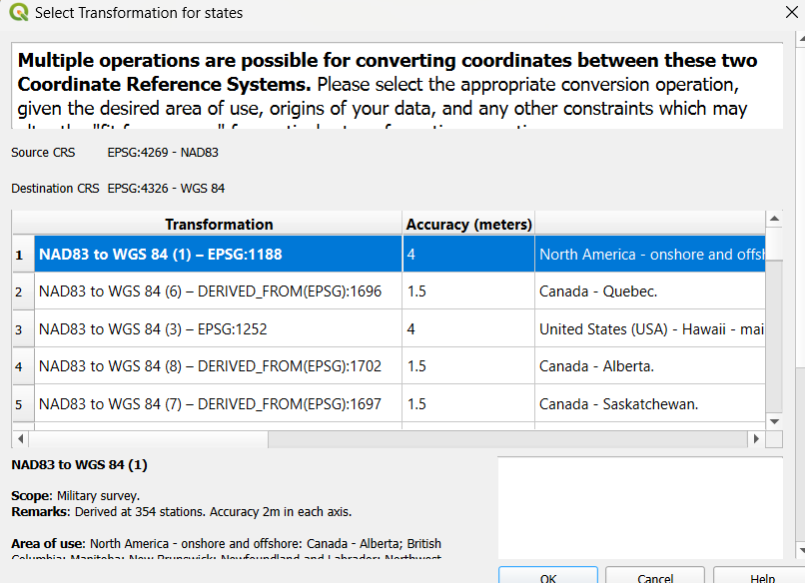

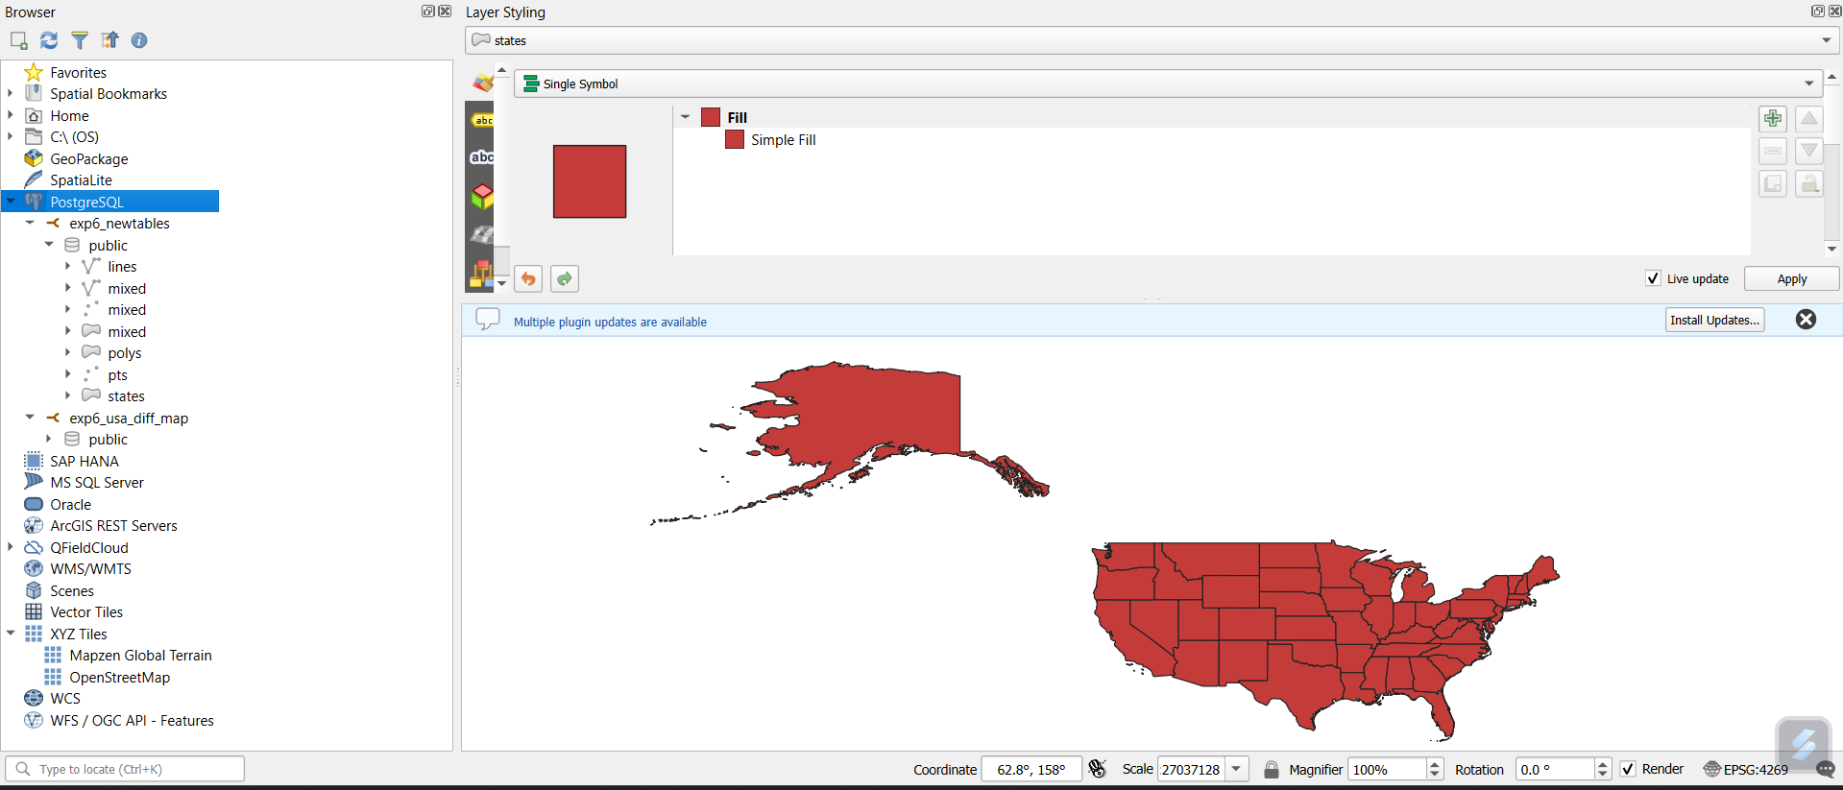

* **Here,** are the new **UPDATED** fields.

**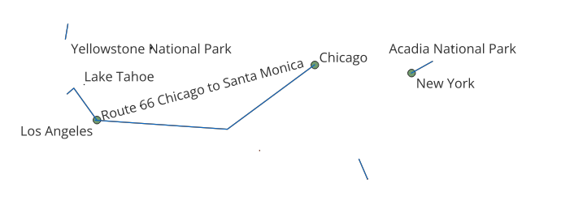**

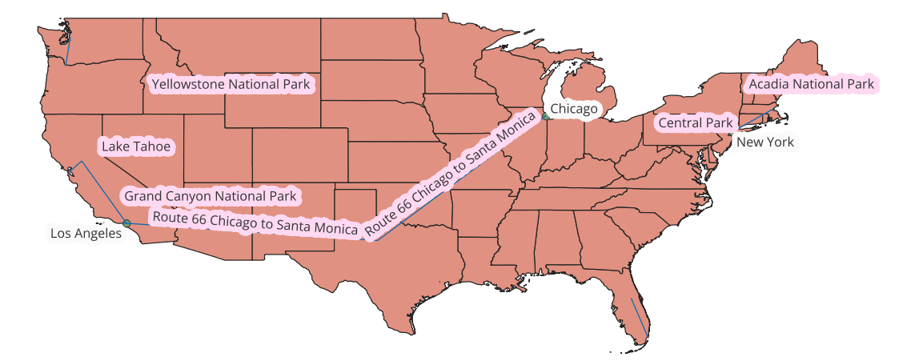

* Explore Basic Functions of QGIS
  + - 1. **Adjust Layer Visibility and Order:**
  + Zoom to full extent: View > Zoom Full.

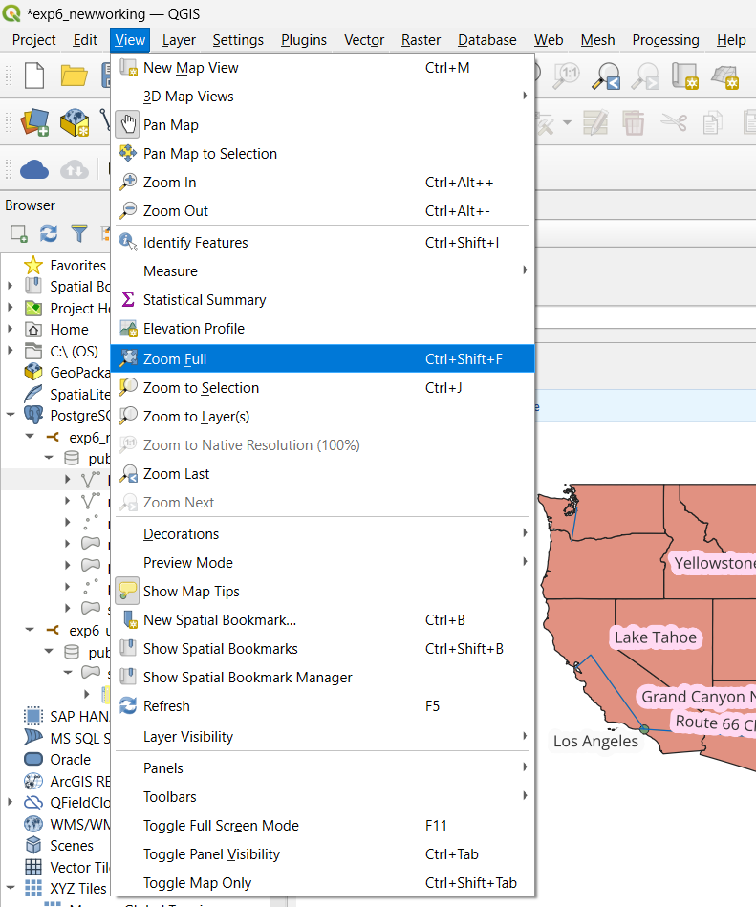

* + Rearrange layers: Drag them to order from top to bottom (e.g., pts, lines, polys, then mixed layers).

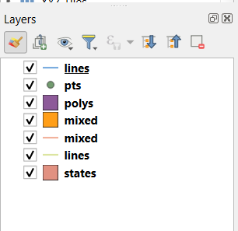

* + Enable/disable layers by clicking the checkbox next to each.

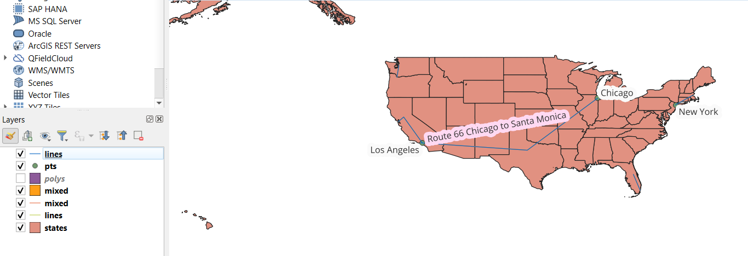

* + - 1. **Rename Layers:** 
         * Right-click mixed layers and select Rename to add distinctions like mixed - lines.

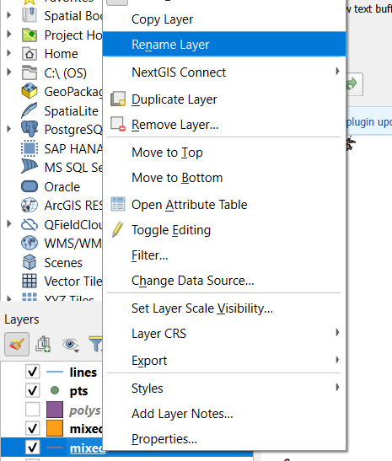

* + - 1. **Apply a Filter to Display Specific Data:**
         * **Double-click** MIXED-LINES and go to the **Source** tab.
         * The Symbology tab is where you'd go to change the way a layer is symbolized. Note the pick list at the very top of the dialog which provides Single Symbol, Categorized, and Graduated options, etc.
         * The **Actions** tab provides functionality similar to ArcGIS's Hyperlink settings for launching external applications to view data found in the attribute table such as images and URLs.
         * The **Joins** tab is where you'd go if you need to join data from another table to the layer's attribute table.
         * The **Diagrams** tab provides settings for creating pie chart and histogram (bar) chart overlays from numeric data in the attribute table.

**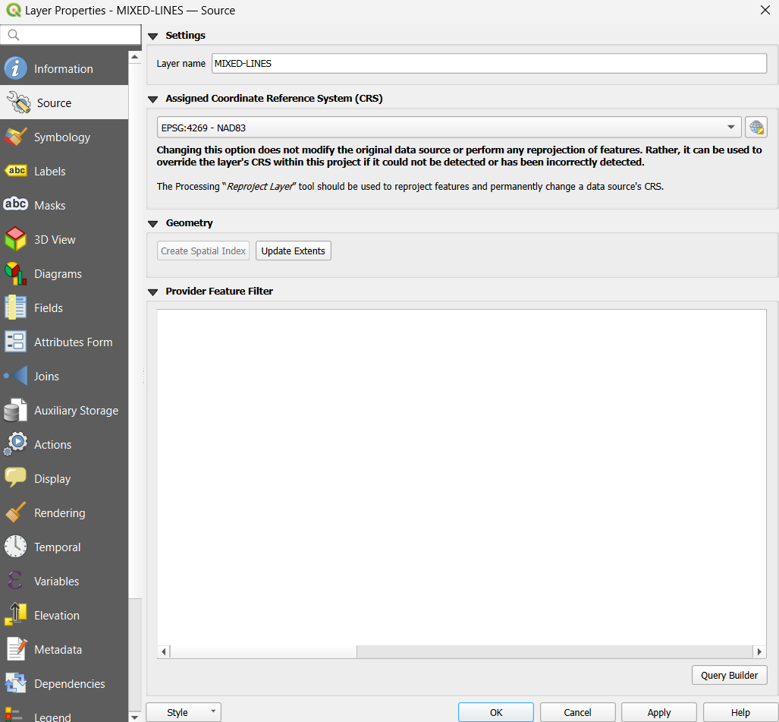**

**s**

* + - * + Click Query Builder, add "name" LIKE '%National Park’ to filter results.
        + Click OK to save and apply the filter.

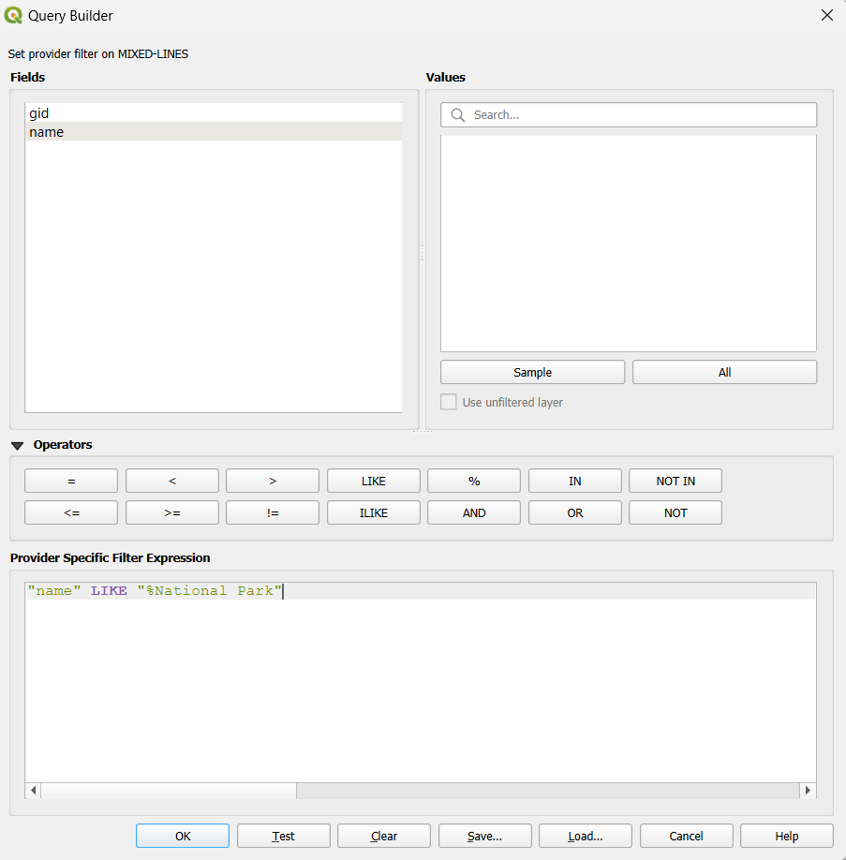

* + - 1. **Using Map Navigation and Selection Tools:**
         * **The Map Navigation Toolbar** (with the Pan tool) lets you zoom and pan.



* + - * + To the right of the Map Navigation toolbar is the **Selection Toolbar**and the **Attributes Toolbar**. The controls on these toolbars include tools for selecting (the layer needs to be highlighted first)/unselecting features, the **Identify Features** tool, a tool for opening the attribute table of the layer selected in the Layers Panel, a Field Calculator, etc.

 

* + - 1. **Open Attribute Table and Filter Features:**
         * Right-click the pts layer, open Attribute Table.

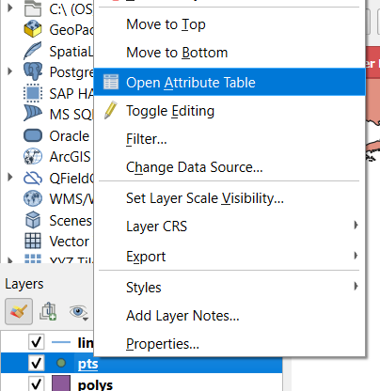

* + - * + Use the Select features using an expression tool to select data with conditions, e.g., gid <=1

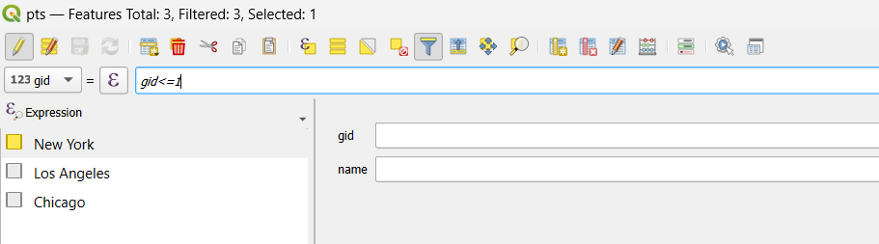

* + - * + Close the Attribute table.
      1. **Adjust Project Properties:**
         * Go to Project > Properties:

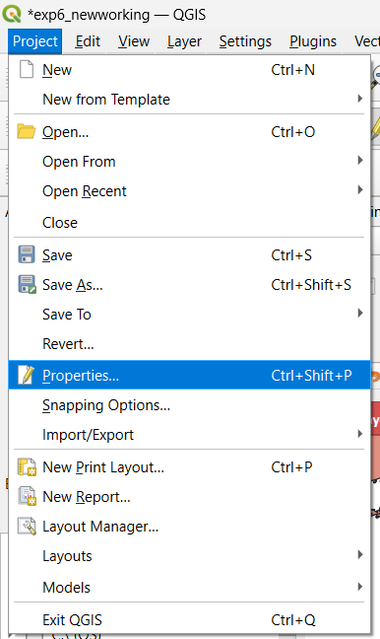

* + - * + Under the **General**tab, you can: set the selection and background colors, specify whether references to data sources should be stored with relative or absolute paths, and set the display units of the project.

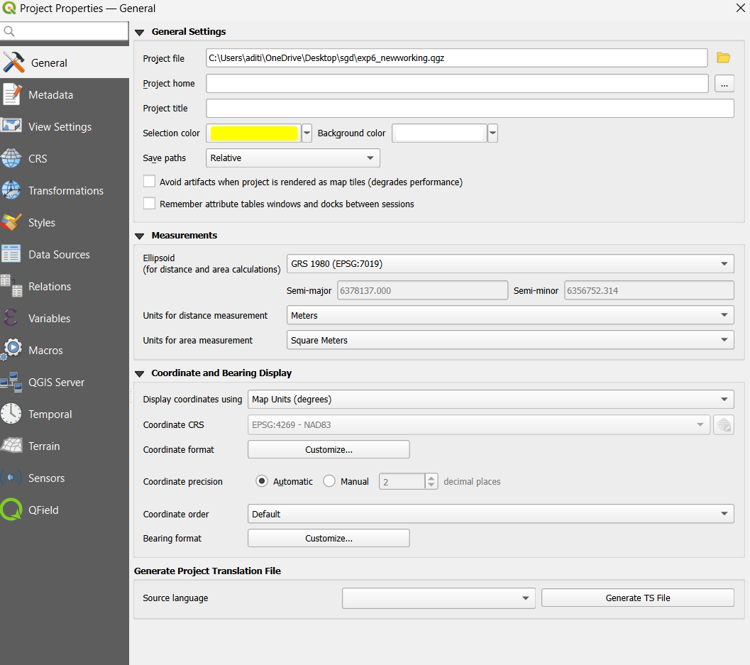

* + - * + Under the**CRS** (Coordinate Reference System) tab, you can specify on-the-fly coordinate system transformation settings. Let's re-project our data into the *New York East State Plane* system.
        + The **Predefined Coordinate Reference Systems**section of the dialog (where you pick a coordinate system) should show that NAD83 (with Authority ID of EPSG:4269) is selected.  This setting was inherited from the first data layer added to the project.
        + Scroll to the top of the list and click the minus sign [-] sign box to collapse the list of **Geographic Coordinate Systems.**This should enable you to see the other major category, **Projected Coordinate Systems**, which is where we'd expect to find the New York East system.

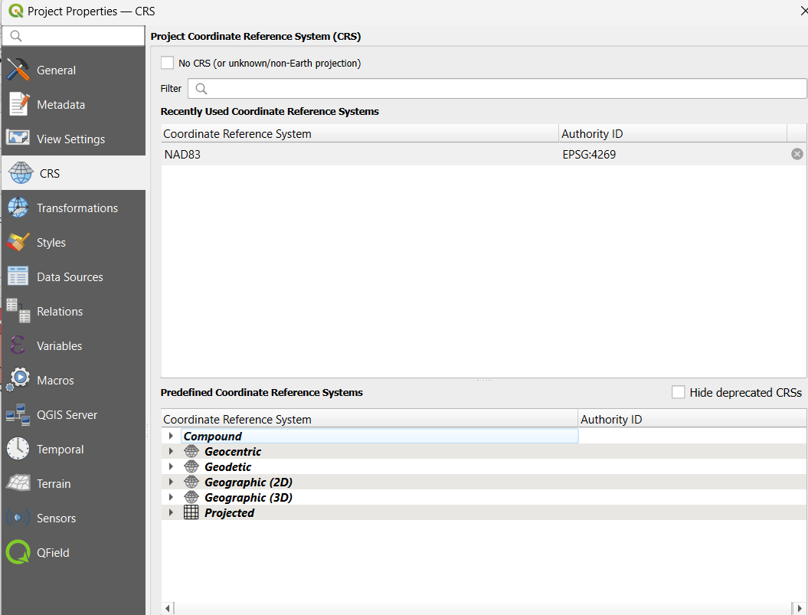

* + - * + QGIS doesn't include a State Plane sub-category in its Projected Coordinate System list; all of the state plane projections can be found in either the Lambert Conformal Conic or Transverse Mercator sub-categories.

 

* + - * + Scrolling through those long lists can be tedious, so go to the **Filter**box near the top of the dialog and enter **new york**. The coordinate system listing should now only include those with 'new york' in the name.
        + Find **NAD83 / New York Long Island EPSG: 32118** under the **Lambert Conformal Conic** category and select it.  Note that the area the coordinate system is designed for is highlighted in red on the mini map at the bottom right of the dialog. 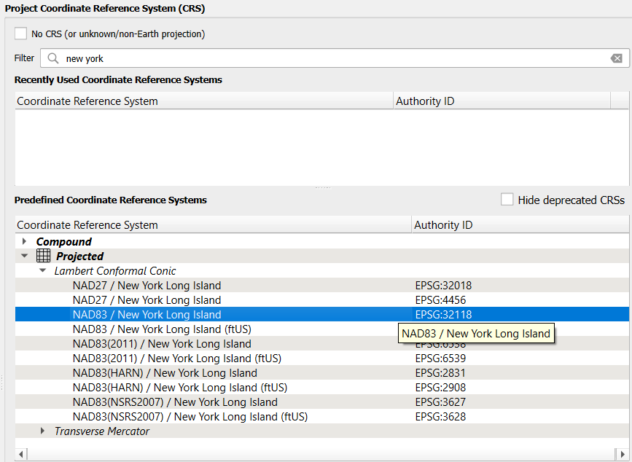
        + Click **OK**to accept the selected CRS. 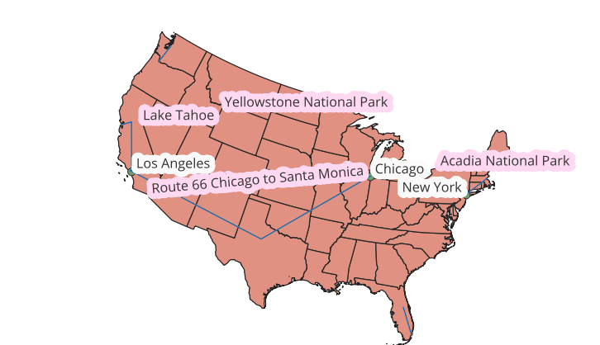
        + Our updated Map wrt to CRS NAD83 / New York Long Island EPSG: 32118
      1. **Save the Project:**

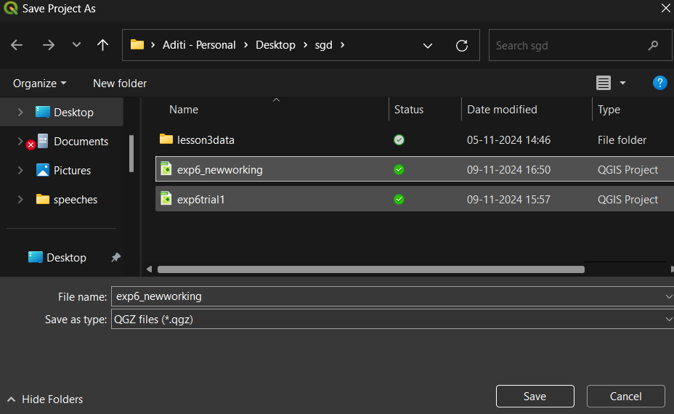

Click the Save button, name your project exp6\_newworking, and save it with the .qgs extension.

***Conclusion:***

*In our sixth experiment, we successfully added* ***PostGIS*** *data to* ***QGIS*** *and explored the functionalities of the software to interact with spatial datasets. The experiment demonstrated how to set up a* ***PostGIS connection in QGIS****,* ***load different data layers****, and* ***apply transformations for datum consistency****.*

*We also practiced basic operations in QGIS, such as filtering data, navigating maps, adjusting layer properties, and working with attribute tables.*

*This exercise highlighted the interoperability between QGIS and PostGIS, showcasing the effectiveness of QGIS as a tool for geospatial analysis and visualization with database-stored spatial data.*

***Some major mistakes and issues faced :***

1. The data that was inserted in the previous experiment might have been faulty as it did not form a proper geom “map”.
2. This further rendered all the tables USELESS. As an alternate solution, a whole new schema with the same category of tables had to be made.
3. This fed with the **right data** from the internet helped in connecting the PostGIS database to QGIS and its subsequent modules of conversion and functionalitys.